CPE316 – Embedded Systems Final Project Report

PERSON TRACKING SYSTEM WITH ESP32

Semester II (2021-2022)

| Course supervisors:  Dr. Iman Elawady  ENG. Michael B.Khani | Team PHOENIX members:  Esmanur ALICAN (1810205066) (1810205066@ogrenci.karabuk.edu.tr)  İrem KARAAYTU(1810205057) (1810205057[@ogrenci.karabuk.edu.tr](mailto:1234567890@ogrenci.karabuk.edu.tr))  Ebru KIRIKKAYIS(1810205089) (1810205089@ogrenci.karabuk.edu.tr)  Yasemin EKER(2017010206002) (2017010206002[@ogrenci.karabuk.edu.tr](mailto:1234567890@ogrenci.karabuk.edu.tr))  Alperen SARIERIKLI(1810205052) (1810205052[@ogrenci.karabuk.edu.tr](mailto:1234567890@ogrenci.karabuk.edu.tr))  Berk Ali MERAL(1810205030) (1810205030[@ogrenci.karabuk.edu.tr](mailto:1234567890@ogrenci.karabuk.edu.tr))  Bilal BERISPAK(1810205032) (1810205032@ogrenci.karabuk.edu.tr)  Fehmi GUNAY (1810205040) (1810205040@ogrenci.karabuk.edu.tr) |
| --- | --- |

* **Introduction**

Our project is a person tracking system with face detection.

Start date:13.04.2022

Finish date: 25.05.2022

This project aims security with tracking the time that a person has spent in a room.

Our project could be used in a place which can be dangerous to stay more than a certain time. For example, a chemistry lab. If a scientist spends a lot of time in the lab more than 5 minutes, the buzzer makes a sound and the LED lights up.

* **Related Works**

Here is how PyImageSearch works;

In this project, facial recognition will be performed on Raspberry Pi and a simple security system will be created that can send us text message alerts when intruders enter the video stream.

To realize this project will be used:

Knowledge (and applications) from PyImageSearch Gurus modules on facial recognition.

Amazon Simple Storage Service (S3) for uploading images of intruders to the cloud.

Twilio API to capture uploaded photos and automatically send them to our smartphone instantly alerts us when intruders enter a sandbox.

Goals:

Leveraging our facial recognition knowledge and applying it to Raspberry Pi.

Determining if an intruder has entered the view of the Raspberry Pi camera, and if so:

Uploading a photo of the intruder to Amazon S3.

Instant sending of a photo of the intruder to our smartphone.

**Summary**

To guard against false positive detections, ensured that the "intruder" was marked "Unknown" for a sufficient number of frames before sending this text message. When implementing code that requires processing a video stream and deriving information from frames, it is good practice to ensure that an event, event, or identification occurs for a predetermined number of frames before sending an alert or taking any other action.

* **Project Design**

Hardware Limits: ESP32 is good for basic applications like just for video streaming but it's not good enough for face recognition or detection. The camera fps is very low when face detection or recognition is on.

Software limits: We used C++ for our project and it is harder compared to Python. It would be better if we could use Python but Ardunio doesn’t support Python.

Another software limit is that we couldn’t use database or we couldn’t use Machine Learning Algorithms or create a new dataset for face detection because ESP32 is not capable of these.

* **Project Layout**

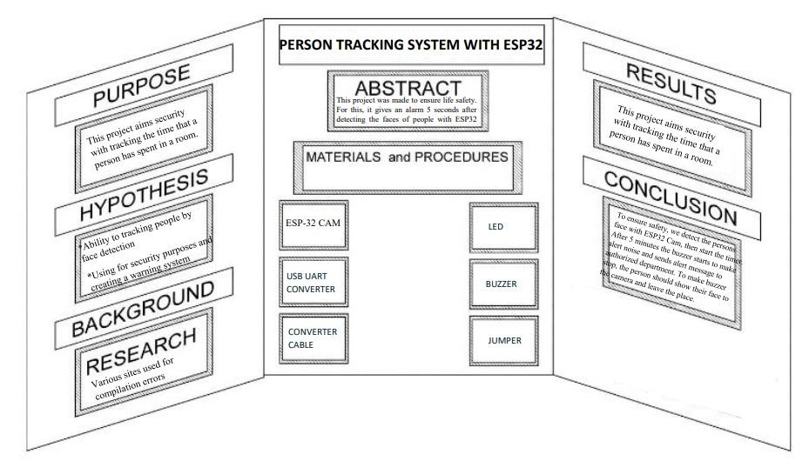

*Figure 1 – Just a sample to see how to demonstrate an infographic*

**Project Mechanism**

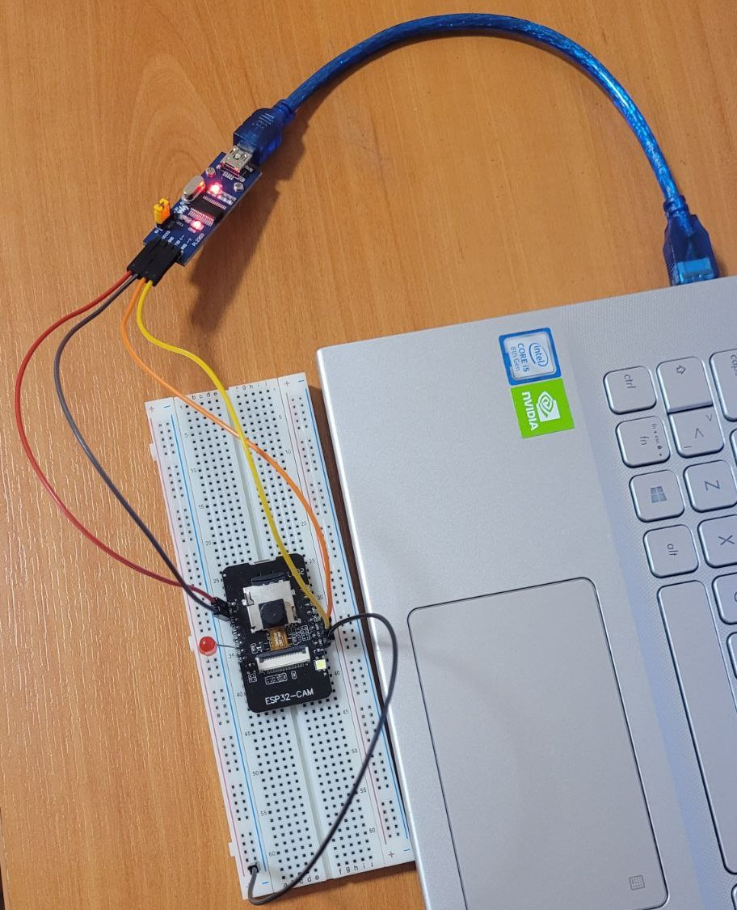

*Figure 2 – Person tracking system with device based on ESP32 diagram*

Here, the project mechanism, diagrams and connections will be demonstrated using suitable figures and descriptions.

* **Conclusion and Results**

This project’s main goal is to provide life safety. To achieve that, we detect the persons face with ESP32 Cam, then start the timer. After 5 seconds, the buzzer starts to make alert noise and sends alert message to authorized department. To make buzzer stop, the person should show their face to the camera and leave the place. When the face detected correctly, the buzzer and timer resets and everything is fine.

We can’t figure out how to send alert messages to authorized departments so couldn’t do that part but this project does all the remaining parts.

This project provides safe entry to dangerous places and helps to prevent any harm that could happen there.

* **Lesson Learnt**

During this project we learnt ;

* How facial recognition systems work and how they are made
* How to do face recognition with OpenCV
* Usage of the Yolo Algorithm
* integrated circuit design
* how this system is integrated into the board.

What we learned about embedded systems;

* Embedded systems provides security on our project
* We had a connection error while connecting the espcam to the computer. But we figured out how to deal with these problems.
* **References**
* <https://www.robotistan.com/>
* <https://towardsdatascience.com/everything-you-ever-wanted-to-know-about-computer-vision-heres-a-look-why-it-s-so-awesome-e8a58dfb641e>
* <https://opencv.org/>
* https://customers.pyimagesearch.com/lesson-sample-face-recognition-for-security/
* **Attachments**

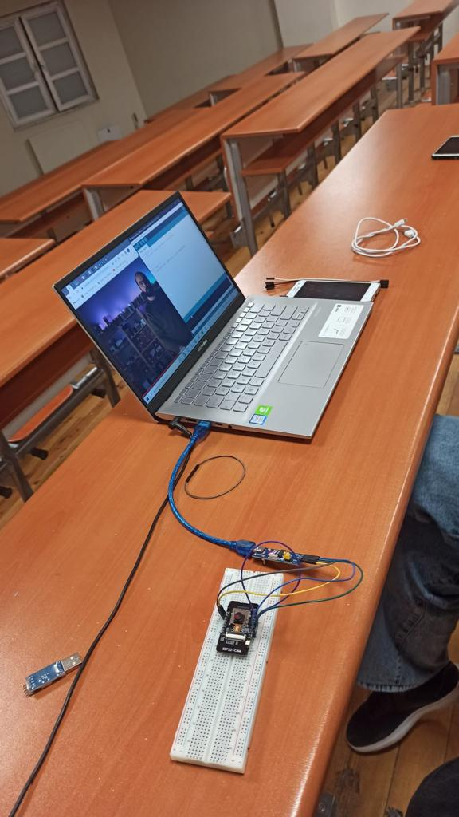

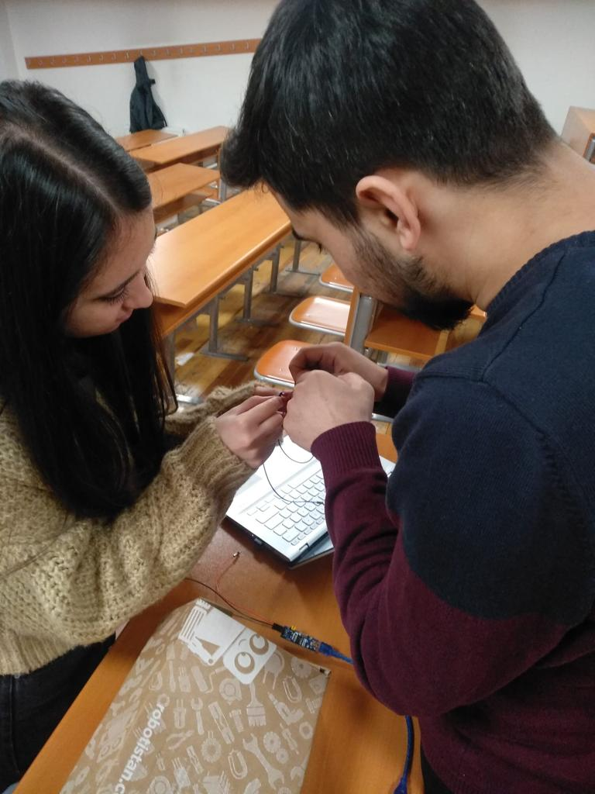

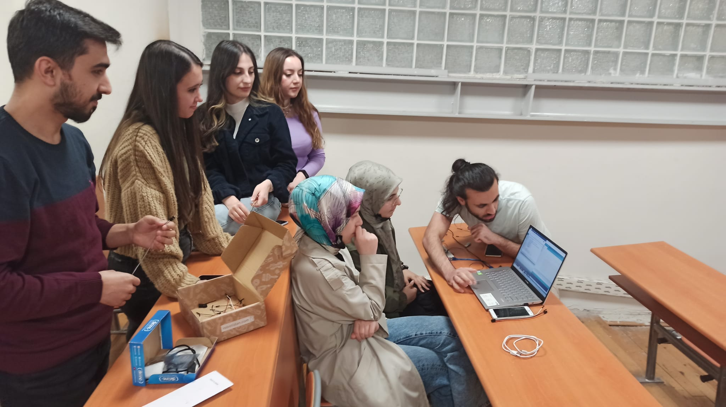

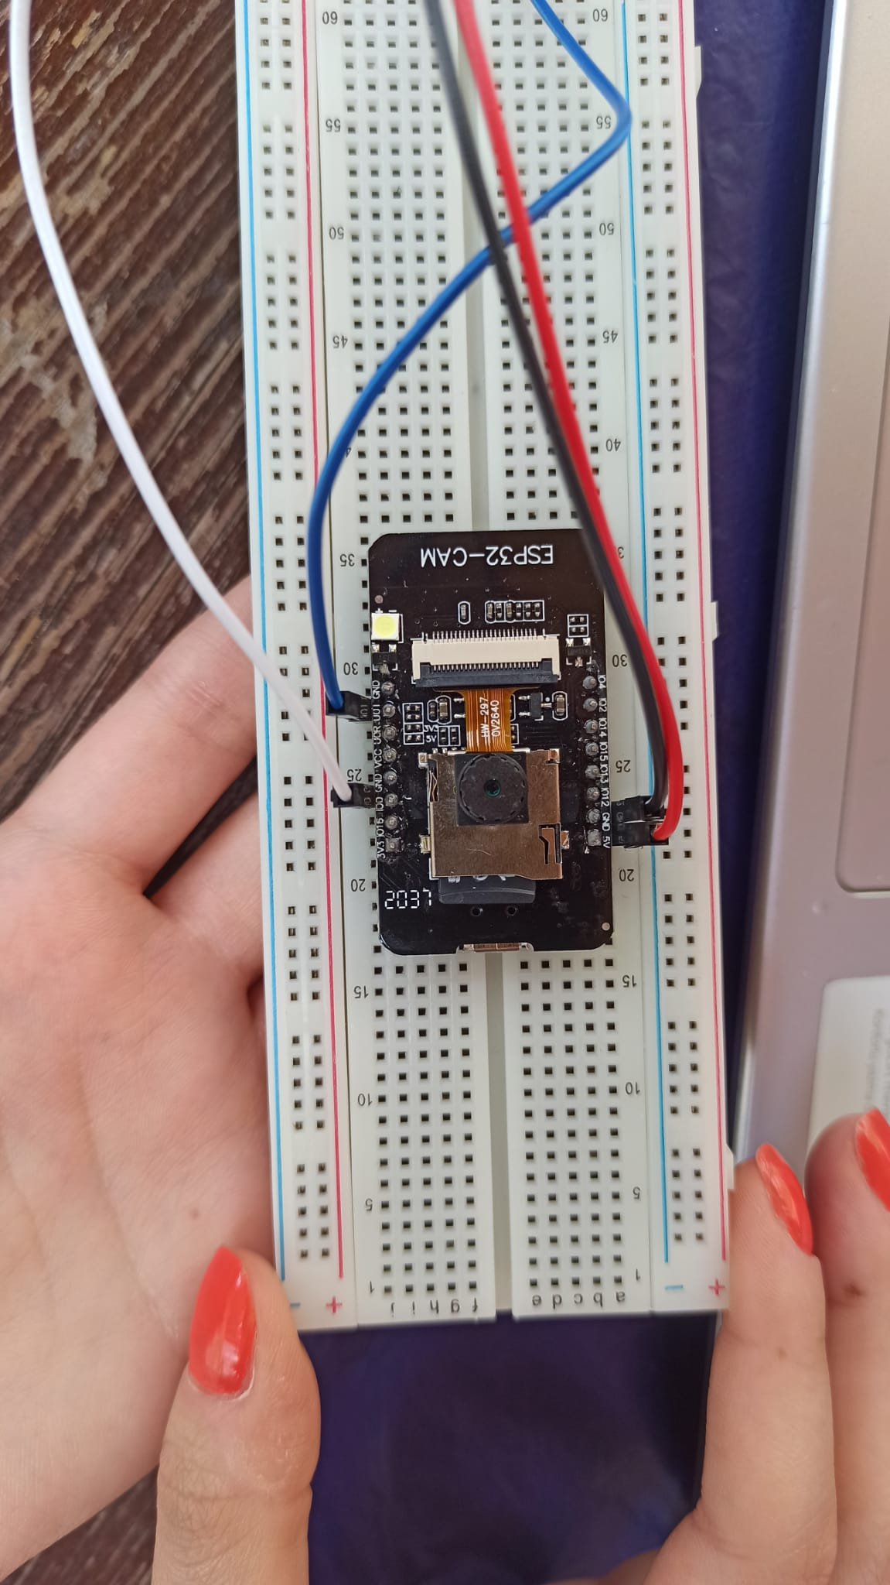

* **Code Modules**

It is attached to the file as a zip.